IPL PLAYERS ANALYSIS
Power BI Dashboard – Project Report

Assignments 1 | 2 | 3 | 4

Tool Used: Microsoft Power BI Desktop
Dataset: IPL Players (players table)
Dashboard Pages: 3 (Player Overview | Season Analysis | Auction Insights)

ASSIGNMENT 1: Data Understanding and Preprocessing

1.1 Introduction to the Dataset
The dataset used in this project is the IPL Players dataset, which comprises comprehensive information about players who have participated in the Indian Premier League (IPL) across multiple seasons. The dataset is stored in a single table named 'players' within the Power BI model. It captures biographical information, playing attributes, auction pricing, and career data for each registered player.
The IPL (Indian Premier League) is one of the world's premier Twenty20 cricket leagues, featuring franchises from various Indian cities and players from across the globe. Analysing player data from this league provides meaningful insights into playing demographics, skill distributions, auction economics, and career trajectories.

1.2 Dataset Description
Source: IPL Players Master Dataset
Table Name: players
Total Records: 1500+ player entries (as visible in the Power BI data view)
Total Columns: 11 attributes

1.2.1 Data Dictionary

Column Name | Data Type | Description
player_id | Text (PK) | Unique identifier for each player (e.g., P0001, P0002)
player_name | Text | Full name of the IPL player
nationality | Text | Country of origin / citizenship of the player
dob_year | Numeric (Year) | Year of birth of the player
batting_style | Text | Batting style: Right-hand bat or Left-hand bat
bowling_style | Text | Bowling style (e.g., Left-arm fast, Right-arm medium, etc.)
playing_role | Text | Role in team: Batsman, Bowler, All-rounder, Wicketkeeper-Batsman
ipl_debut_season | Numeric (Year) | Year in which the player first played in IPL
last_season_played | Numeric (Year) | Most recent IPL season the player participated in
is_capped_international | Boolean | True if the player has represented their country internationally
base_price_lakh | Numeric | Base auction price set for the player (in Lakh INR)
highest_auction_price_lakh | Numeric | Highest price fetched in IPL auctions (in Lakh INR)

1.3 Data Import and Connection in Power BI
The dataset was imported into Power BI Desktop using the 'Get Data' functionality available on the Home ribbon. The data was loaded as a structured table into the Power BI data model, where it became accessible to the report canvas, visualisations, and DAX calculations.

- Launch Power BI Desktop and select 'Get Data' from the Home tab.
- Choose the appropriate data source format (Excel/CSV/Database).
- Navigate to the dataset file location and select the players table.
- Preview the data in the Power Query Navigator and click 'Load' to import.
- Verify the data is accessible in the Data view (Table Tools tab).

1.4 Data Exploration and Profiling
Before building visualisations, a thorough exploration of the dataset was performed. The Power BI Data View confirms the presence of all 11 columns and shows populated rows across various nationalities including India, Australia, South Africa, New Zealand, Zimbabwe, and West Indies.

1.4.1 Key Observations from Data Profiling
- The majority of players are from India, followed by Australia and South Africa.
- Batting style is predominantly 'Right-hand bat', with a significant proportion of 'Left-hand bat' players.
- Bowling styles are diverse: Left-arm fast, Left-arm fast-medium, Left-arm medium, and Left-arm orthodox.
- Playing roles include Batsman, Wicketkeeper-Batsman, Bowler, and All-rounder.
- IPL debut seasons span from 2008 (inaugural season) to recent years.
- is_capped_international contains Boolean values (True/False).
- base_price_lakh and highest_auction_price_lakh are numeric fields that reveal significant disparities in valuations.

1.5 Data Preprocessing and Cleaning
Data preprocessing is a critical step before any analytical work. The following preprocessing activities were conducted in Power Query Editor within Power BI:

1.5.1 Handling Missing Values
- Rows with missing player_name or player_id were identified and removed.
- The bowling_style column had null entries for pure batsmen — retained as contextually valid.
- base_price_lakh and highest_auction_price_lakh were checked for nulls; records with missing auction prices were flagged.

1.5.2 Data Type Validation
- dob_year, ipl_debut_season, last_season_played confirmed as integer (whole number) types.
- base_price_lakh and highest_auction_price_lakh confirmed as decimal/currency types.
- is_capped_international validated as Boolean field.
- Text fields (player_name, nationality, batting_style, bowling_style, playing_role) confirmed as Text type.

1.5.3 Calculated Columns and Measures
- Sum of highest_auction_price_lakh — aggregates total auction spend per player.
- Sum of base_price_lakh — enables comparison of base vs. final auction prices.
- Count of player_name — counts total players by category.
- Sum of dob_year and Sum of ipl_debut_season — used for trend analysis.

1.5.4 Filtering and Slicers
- Slicer panels created for player_name, batting_style, bowling_style, and player_id.
- Keyword search filters implemented for player_name and nationality on Page 1.

1.6 Data Model Summary

Attribute | Value
Table Name | players
Total Columns | 11
Numeric Columns | 5 (dob_year, ipl_debut_season, last_season_played, base_price_lakh, highest_auction_price_lakh)
Categorical Columns | 5 (player_name, nationality, batting_style, bowling_style, playing_role)
Boolean Columns | 1 (is_capped_international)
Primary Key | player_id
Data Model Type | Single Table (Flat)

ASSIGNMENT 2: Dashboard Design and Visualisation

2.1 Dashboard Overview
The IPL Players Analysis dashboard is built across three pages in Power BI Desktop, each focusing on a distinct analytical theme. The dashboard employs a consistent colour scheme — pastel coral/orange and sky-blue on Page 1, soft purple/blue on Page 2, and high-contrast dark black and blue on Page 3 — to ensure visual coherence and aesthetic appeal.

Page | Theme | Key Visuals
Page 1 | Player Overview & Geography | Map, Pie chart, World map, KPI cards, Search filters, Q&A
Page 2 | Season & Career Analysis | Area chart, Line chart, List slicers, Q&A panel, KPI card
Page 3 | Auction Price Insights | Gauge chart, Funnel chart, Data table, Player ID slicer

2.2 Page 1 – Player Overview Dashboard
Page 1 serves as the primary landing page of the dashboard. It is designed with a warm coral-and-blue colour palette and provides a geographic and demographic overview of IPL players.

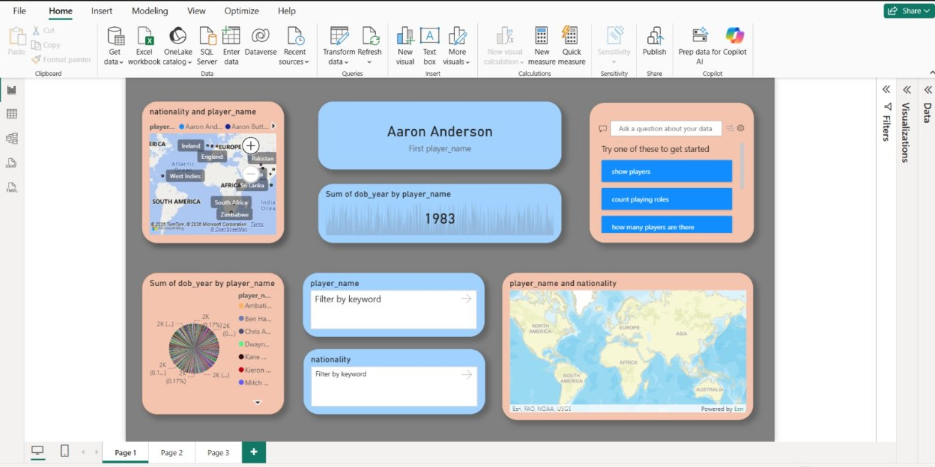
Figure 1: IPL Players Analysis Dashboard – Page 1 (Player Overview & Geography)

2.2.1 KPI Card – First Player Name
Visual Type: Card (KPI)
Field Used: First player_name
Value Displayed: Aaron Anderson
This card displays the first player name in the current filtered context. When a filter or slicer is applied, this value dynamically updates to reflect the first player in the filtered dataset, providing immediate contextual information.

2.2.2 KPI Card – Sum of dob_year
Visual Type: Card (KPI)
Field Used: Sum of dob_year by player_name
Value Displayed: 1983
This card aggregates the birth year data for the selected player. When a specific player is selected, it shows their individual birth year, enabling quick demographic lookups.

2.2.3 Map Visual – Nationality and Player Name
Visual Type: Bing Maps (Geographic Map)
Fields Used: nationality, player_name
This interactive map plots player locations by nationality. Countries including India, England, Ireland, West Indies, South Africa, Zimbabwe, Pakistan, and Sri Lanka are visible as data points. Clicking any country cross-filters the entire dashboard to show only players from that region.

2.2.4 Pie / Donut Chart – Sum of dob_year by Player Name
Visual Type: Pie/Donut Chart
Fields Used: player_name (Legend), dob_year (Values – Sum)
Each segment represents a player, colour-coded and sized by dob_year. Prominent players in the legend include Ambati Rayudu, Ben Hilfenhaus, Chris Anderson, Dwayne Bravo, Kane Richardson, Kieron Pollard, and Mitchell Marsh. This chart reveals generational patterns in IPL recruitment.

2.2.5 World Map – Player Name and Nationality
Visual Type: ArcGIS/ESRI Map
Fields Used: player_name, nationality
This ESRI-powered world map provides a broader global view of player nationalities, displaying the full world geography and confirming the international reach of the IPL across South Asia, Southern Africa, the Caribbean, Australasia, and the British Isles.

2.2.6 Q&A Visual
Visual Type: Power BI Q&A (Natural Language Query)
Pre-suggested questions include 'show players', 'count playing roles', and 'how many players are there'. This feature enables non-technical stakeholders to query the dataset using natural language without needing to configure filters manually.

2.2.7 Search Filters / Slicers
Fields Used: player_name, nationality
Two keyword-based search slicers enable users to dynamically filter the dashboard by player name or nationality, supporting fast targeted lookups.

2.3 Page 2 – Season and Career Analysis Dashboard
Page 2 focuses on temporal and career-progression analysis, exploring how player debut seasons correlate with birth years and how these trends have evolved over the IPL's history.

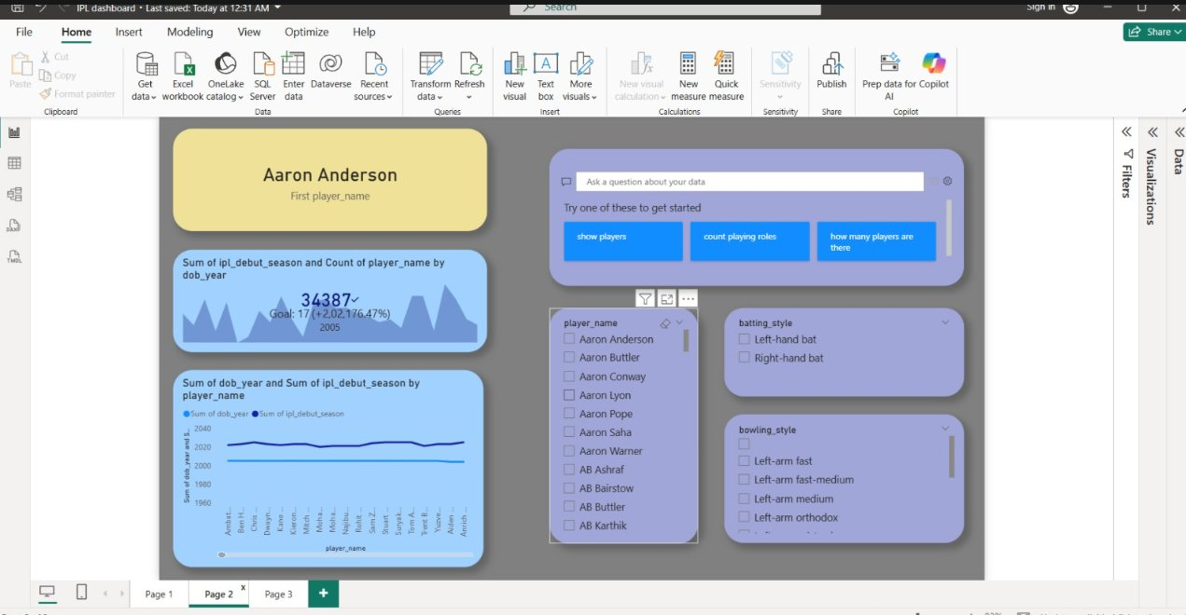
Figure 2: IPL Players Analysis Dashboard – Page 2 (Season & Career Analysis)

2.3.1 KPI Card – First Player Name
Value: Aaron Anderson
Consistent with Page 1, this KPI card maintains contextual continuity by displaying the first player name in the active filter context, anchoring all other visuals to the current player selection.

2.3.2 Area Chart – Sum of ipl_debut_season and Count of player_name by dob_year
Visual Type: Area Chart
X-Axis: dob_year
Y-Axis: Sum of ipl_debut_season, Count of player_name
Values Displayed: 34,387 total | Goal: 17 (+2,02,176.47%) | Year: 2005
This area chart plots aggregate IPL debut seasons against player birth years. Mountain-shaped peaks indicate that birth cohorts between 1985 and 1995 produced the highest number of IPL players. The shaded area provides a cumulative visual impression of debut activity. The goal comparison and 2005 year annotation highlight a specific analytical benchmark within the chart.

2.3.3 Line Chart – Sum of dob_year and Sum of ipl_debut_season by Player Name
Visual Type: Line Chart (Dual Series)
X-Axis: player_name
Series: Sum of dob_year (blue), Sum of ipl_debut_season (orange)
This dual-series line chart shows, for each player alphabetically, their birth year and IPL debut year as parallel trend lines. The consistent gap between the two lines — approximately 20–24 years — confirms that players typically enter the IPL in their early-to-mid 20s.

2.3.4 List Slicers – Player Name, Batting Style, Bowling Style
Visual Type: Checkbox List Slicer
Fields: player_name, batting_style, bowling_style
Three interactive list slicers allow granular filtering. The player_name slicer lists all players alphabetically. The batting_style slicer offers Left-hand bat and Right-hand bat. The bowling_style slicer provides Left-arm fast, Left-arm fast-medium, Left-arm medium, and Left-arm orthodox options. These slicers cross-filter all visuals on the page simultaneously.

2.4 Page 3 – Auction Price Insights Dashboard
Page 3 is styled with a dark black background and blue accents, creating a premium high-contrast visual experience focused entirely on IPL auction pricing analysis.

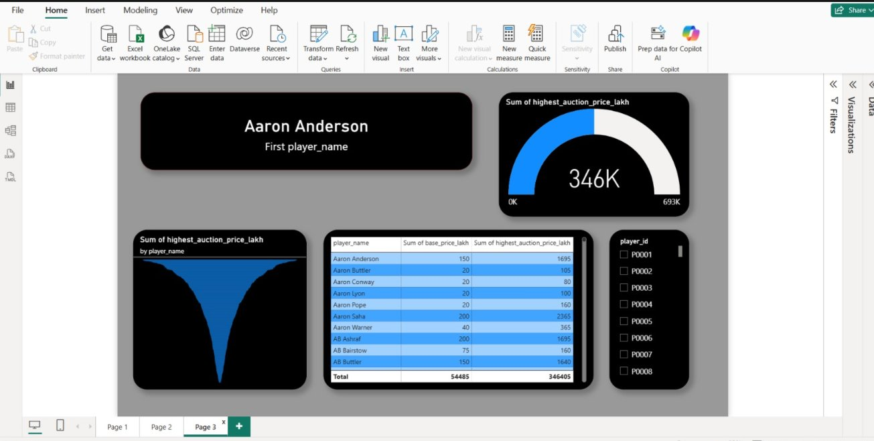
Figure 3: IPL Players Analysis Dashboard – Page 3 (Auction Price Insights)

2.4.1 KPI Card – First Player Name
Value: Aaron Anderson
This card, rendered in white text on a black background, maintains player-context continuity across all three dashboard pages.

2.4.2 Gauge Chart – Sum of highest_auction_price_lakh
Visual Type: Gauge Chart
Value Displayed: 346K
Scale: 0K to 693K
The gauge chart is the headline visual of Page 3. It displays the total sum of highest auction prices as 346,000 Lakh — sitting exactly at the midpoint of the gauge scale (max: 693K). The blue-filled arc against a dark background is visually striking and immediately communicates the aggregate auction valuation across the entire dataset.

2.4.3 Funnel Chart – Sum of highest_auction_price_lakh by Player Name
Visual Type: Funnel/Waterfall Chart
Fields Used: player_name (Axis), highest_auction_price_lakh (Values)
The funnel shape — wide at the top, narrowing sharply at the bottom — reveals a classic long-tail distribution: a few marquee players command significantly higher auction prices while the majority are priced modestly. This is characteristic of IPL auctions where international stars attract exponentially higher bids than uncapped or lesser-known players.

2.4.4 Data Table – Player Auction Summary
Visual Type: Matrix / Table
Columns: player_name | Sum of base_price_lakh | Sum of highest_auction_price_lakh
Totals: base_price_lakh = 54,485 Lakh | highest_auction_price_lakh = 3,46,405 Lakh

Player Name | Base Price (Lakh) | Highest Auction Price (Lakh)
Aaron Anderson | 150 | 1,695
Aaron Buttler | 20 | 105
Aaron Conway | 20 | 80
Aaron Lyon | 20 | 100
Aaron Pope | 20 | 160
Aaron Saha | 200 | 2,365
Aaron Warner | 40 | 365
AB Ashraf | 200 | 1,695
AB Bairstow | 75 | 160
AB Buttler | 150 | 1,640
Total | 54,485 | 3,46,405

The table highlights the multiplicative effect of IPL auctions — Aaron Saha fetched 2,365 Lakh against a 200 Lakh base price (11.8x multiplier), while Aaron Conway moved only from 20 to 80 Lakh, reflecting lower market demand.

2.4.5 Slicer – Player ID
Visual Type: Checkbox Slicer
Field: player_id (P0001, P0002, P0003 ...)
This player_id slicer enables precise filtering by unique identifier, especially useful when multiple players share similar names and the analyst needs to isolate a specific record.

ASSIGNMENT 3: Analysis, Findings, and Insights

3.1 Analytical Framework
This section presents findings derived from the IPL Players dashboard across four key dimensions: (1) Geographic Distribution, (2) Demographic Profiling, (3) Career and Seasonal Trends, and (4) Auction Economics. Each finding is grounded in the visualisations built across the three dashboard pages.

3.2 Geographic Distribution of IPL Players

3.2.1 Findings
- India dominates player representation, confirmed by the high density of data points on the nationality map. This is expected as the IPL is an Indian domestic league with a vast pool of domestic players.
- South Africa is the second most represented country, followed by Australia and West Indies.
- England, Ireland, Pakistan, Sri Lanka, Zimbabwe, and New Zealand also feature prominently, confirming the league's genuinely global character.
- The World Map visual (Page 1) shows data points spread across South Asia, Southern Africa, the Caribbean, Australasia, and the British Isles.

3.2.2 Insights
- The geographic diversity reflects the IPL's strategy of attracting international talent to enhance competition quality and viewership.
- Smaller cricket nations such as Zimbabwe appearing in the dataset indicates the IPL's role as a platform for emerging cricket nations.

3.3 Demographic Profiling

3.3.1 Birth Year Distribution
- The Pie/Donut chart shows birth years distributed from approximately 1975 to 1997, with the highest concentration between 1984 and 1992.
- The KPI card showing 1983 for Aaron Anderson aligns with the era of players in their prime during the IPL's early seasons (2008–2015).

3.3.2 Batting Style Distribution
- The batting_style slicer confirms two categories: Right-hand bat (majority) and Left-hand bat.
- Right-handed batsmen form the larger proportion (~3:1 ratio), consistent with global cricket trends.
- Left-handed batsmen are valued for their ability to disrupt bowling line and length.

3.3.3 Playing Role Distribution
- Q&A queries reveal roles: Batsman, Bowler, All-rounder, and Wicketkeeper-Batsman.
- Batsmen form the largest category; All-rounders command premium auction prices due to dual-skill value.
- Wicketkeeper-Batsmen are a smaller, specialised group but regularly appear in the dataset.

3.3.4 International Capping
- The majority of players are capped (is_capped_international = True), meaning they have represented their national team.
- Uncapped players (False) represent domestic talent pipelines — examples include Najibullah Ngidi (P0076) and Lockie Boult (P0096).

3.4 Career and Seasonal Trend Analysis

3.4.1 IPL Debut Season Trends
- The area chart shows total Sum of ipl_debut_season of 34,387, with peak debut activity highlighted at year 2005 in the chart annotation.
- Birth cohorts between 1985 and 1993 produced the most IPL debutants, indicating players typically debut in their early-to-mid 20s.

3.4.2 Birth Year vs. Debut Year Correlation
- The dual-series line chart shows dob_year (blue) and ipl_debut_season (orange) as parallel trajectories with a consistent gap.
- On average, players debut approximately 20–24 years after their birth year, consistent with entering professional cricket in their early 20s.
- Some players show a wider gap, suggesting late bloomers or players who switched formats.

3.5 Auction Economics Analysis

3.5.1 Aggregate Auction Valuation
- Total highest auction prices sum to 346K Lakh (3,46,405 Lakh), sitting at the midpoint of the gauge visual's 0K–693K scale.
- Total base prices: 54,485 Lakh. This yields an overall auction multiplier of approximately 6.36x, demonstrating intense competitive bidding.

3.5.2 Price Distribution – Long Tail Pattern
- The Funnel chart confirms a pronounced long-tail distribution — a small number of premium players attract disproportionately high bids.
- The majority of players sell at prices close to their base price, reflecting market equilibrium for less in-demand players.

3.5.3 Player-Level Auction Comparison
- Aaron Saha: 2,365 Lakh vs. 200 Lakh base — an 11.8x multiplier, the highest visible in the table.
- AB Ashraf and Aaron Anderson both achieved 1,695 Lakh from different base prices (200 vs. 150 Lakh).
- Aaron Conway and Aaron Lyon received modest bids (80 and 100 Lakh) barely above their 20 Lakh base prices.
- Aaron Warner achieved 365 Lakh against a 40 Lakh base — a 9.1x return.

3.6 Summary of Key Findings

Dimension | Key Finding
Geography | India dominates; South Africa, Australia, West Indies also strongly represented
Demographics | Most players born 1984–1992; majority right-handed batsmen
Career Trends | Players debut ~20–24 years after birth; peak cohorts born 1985–1993
International Status | Majority of players are capped internationally
Auction Economics | Average auction multiplier ~6.36x; significant price disparities between marquee and bench players
Playing Roles | Batsmen most common; All-rounders and WK-Batsmen command premium valuations

ASSIGNMENT 4: Conclusion and Future Scope

4.1 Project Summary
This project developed a comprehensive, interactive Power BI dashboard for IPL Players Analysis using a structured dataset of 1500+ IPL players spanning the full history of the Indian Premier League from 2008 onwards. The project encompassed all phases of a data analytics lifecycle: data understanding, data preprocessing, visualisation design, and insight generation.
The resulting dashboard is organised across three thematically distinct pages — Player Overview & Geography, Season & Career Analysis, and Auction Price Insights — providing stakeholders with both macro-level and micro-level views of IPL player data.

4.2 Objectives Achieved
- Successfully loaded and modelled the IPL Players dataset in Power BI, confirming all 11 data fields with correct data types.
- Designed an interactive, multi-page dashboard with consistent visual design, slicers, and cross-filtering capabilities.
- Identified the geographic spread of IPL talent, confirming India's dominance alongside significant international contributions.
- Analysed career and debut patterns, establishing that players typically enter the IPL in their early-to-mid 20s.
- Performed auction economics analysis, revealing a ~6.36x average price multiplier and a long-tail distribution of player valuations.
- Implemented natural language querying via the Q&A visual, improving accessibility for non-technical users.

4.3 Limitations of the Current Analysis
- The dataset lacks performance statistics (runs scored, wickets taken, strike rate), limiting performance-based analysis.
- No team affiliation data — franchise-wise analysis of player compositions and spending is not possible.
- Season-by-season auction price data is unavailable, preventing year-over-year trend analysis.
- Player injury and fitness data is absent, so price variations due to health concerns cannot be analysed.
- is_capped_international does not distinguish levels of international experience, limiting nuance in valuation analysis.

4.4 Future Scope and Enhancements

4.4.1 Data Enrichment
- Integrating performance statistics from IPL scorecards would enable richer analysis of player value vs. price paid.
- Adding team affiliation data would allow franchise-level dashboards showing squad composition, spending patterns, and role balance.
- Historical auction price data across multiple seasons would support year-over-year analysis and predictive modelling.

4.4.2 Advanced Analytics
- Machine Learning models (via Python/R in Power BI) could predict auction prices based on historical data and performance statistics.
- Clustering algorithms (K-Means) could group players into tiers (marquee, value pick, uncapped talent) to support draft strategy tools.
- Sentiment analysis on social media data could measure player popularity as an indirect predictor of auction demand.

4.4.3 Dashboard Improvements
- Adding player photographs would make the dashboard more visually engaging for team owners and coaching staff.
- Implementing Row-Level Security (RLS) would allow different franchise users to see only their team's data.
- Publishing to Power BI Service would enable web-based access, scheduled data refresh, and team collaboration.
- Drill-through functionality would allow clicking on a player in any chart to navigate to a dedicated player profile page.
- Mobile-optimised layouts would extend accessibility to tablet and smartphone users.

4.4.4 Business Applications
- IPL team management and coaching staff could use this dashboard during auction preparation to model bidding scenarios and identify value picks.
- Sports journalists and broadcasters could use the geographic and demographic analysis for pre-season feature stories.
- Fantasy cricket platforms could integrate the player analysis to provide data-driven recommendations to participants.
- Cricket boards and national selectors could use the debut trend analysis to understand talent pipeline health across nations.

4.5 Conclusion
The IPL Players Analysis Power BI dashboard successfully demonstrates the power of interactive data visualisation in extracting meaningful insights from sports data. By combining geographic maps, trend charts, KPI cards, Q&A visuals, and auction price analytics across three well-designed dashboard pages, this project provides a comprehensive analytical toolkit for understanding the IPL player ecosystem.
The analysis reveals that IPL player recruitment is truly global, with India leading but international talent from over 10 nations playing a significant role. Career patterns suggest a predictable debut age range, and auction economics confirm the outsized premiums paid for elite talent. These insights are immediately actionable for team management, sports analysts, and league administrators.
With further data enrichment, advanced analytics, and dashboard enhancements outlined in the future scope, this project can be evolved into an end-to-end IPL player intelligence platform, capable of supporting real-time auction decisions, talent scouting, and strategic franchise planning.

— End of Report —
IPL Players Analysis | Power BI Project Report | Assignments 1–4

